INDIAN SCHOOL AL WADI AL KABIR
Worksheet, 2023-24
Class: XII | SUB: INFORMATICS PRACTICES | Date of Completion:
Worksheet No:8 | TOPIC : Computer Networks | Note:
1. What is a network? What are its advantages?
2. What are the different types of Networks?
3. Explian the functions of the following devices:
1. Hub 2. Switch 3. Repeater 4. Gateway 5. Modem 6. NIC 7. Router
4. What is topology ?
5. What is the difference between bus and star topologies? Give two advantages and disadvantages of
each

6. What is the difference between static and dynamic webpages?
7. What is the difference between website and webpage?
8. What is web server and web browser ?
9. Explain web hosting?
10. What are cookies?
11. Helping Hands is an NGO with its head office at Mumbai and branches located at Delhi, Kolkata
and Chennai. Their Head Office located at Delhi needs a communication network to be established
between the head office and all the branch offices. The NGO has received grant approval from the
Central Government for setting up the network. The physical distances between the branch offices
and the head office and the number of computers to be installed in each of these branch offices and
the head office are given below. As a network expert you have to suggest the best possible
solutions for the queries as raised by the NGO, as given in (i) to (iv).
Distances between various locations in Kilometres :
Mumbai H.O. to Delhi 1420
Mumbai H.O. to Kolkata 1640
Mumbai H.O. to Chennai 2710
Delhi to Kolkata 1430
Delhi to Chennai 1870
Chennai to Kolkata 1750

Number of Computers installed at various locations are as follows :
Mumbai H.O. 2500
Delhi Branch 1200
Kolkata Branch 1300
Chennai Branch 1100
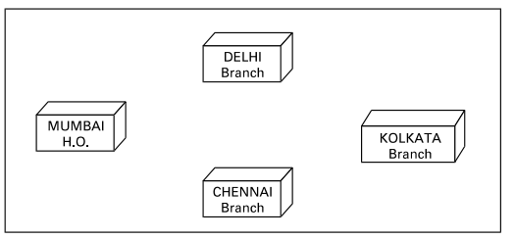
(i) Suggest the drawing the best cable layout for effective network connectivity of all the Branches and the Head Office for communicating data.
(ii) Suggest the most suitable location to install the main server of this NGO to communicate data with all the offices.
(iii) Write the name of the type of network out of the following, which will be formed by connecting all the computer systems across the network :
(A) WAN
(B) MAN
(C) LAN
(D) PAN
(iv) Suggest the most suitable medium for connecting the computers installed across the network out of the following :
(A) Optical fibre
(B) Telephone wires
(C) Radio Waves
(D) Ethernet cable
12. Ayurveda Training Educational Institute is setting up its centre in Hyderabad with four specialised departments for Orthopedics, Neurology and Pediatrics along with an administrative office in
separate buildings. The physical distances between these department buildings and the number of computers to be installed in these departments and administrative office are given as follows. You, as a network expert, have to answer the queries as raised by them in (i) to (iv).
Shortest distances between various locations in metres :
Administrative Office to Orthopedics Unit 55
Neurology Unit to Administrative Office 30
Orthopedics Unit to Neurology Unit 70
Pediatrics Unit to Neurology Unit 50
Pediatrics Unit to Administrative Office 40
Pediatrics Unit to Orthopedics Unit 110
Number of Computers installed at various locations are as follows :
Pediatrics Unit 40
Administrative Office 140
Neurology 50
Orthopedics Unit 80

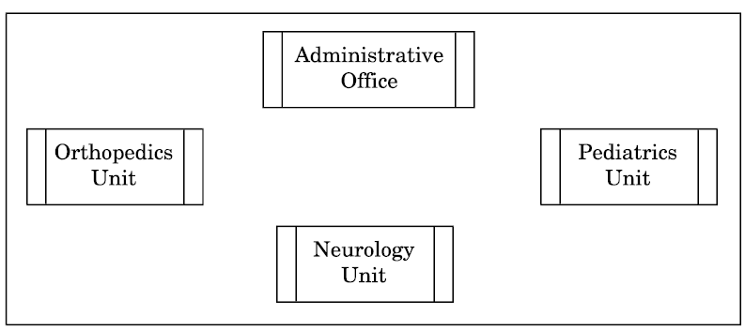

(i) Suggest the most suitable location to install the main server of this institution to get efficient connectivity.
(ii) Suggest the best cable layout for effective network connectivity of the building having server with all the other buildings.
(iii) Suggest the devices to be installed in each of these buildings for connecting computers installed within the building out of the following :
• Gateway
• Modem
• Switch
(iv) Suggest the topology of the network and network cable for efficiently connecting each computer installed in each of the buildings out of the following :
Topologies : Bus Topology, Star Topology
Network Cable : Single Pair Telephone Cable, Coaxial Cable, Ethernet Cable
13.
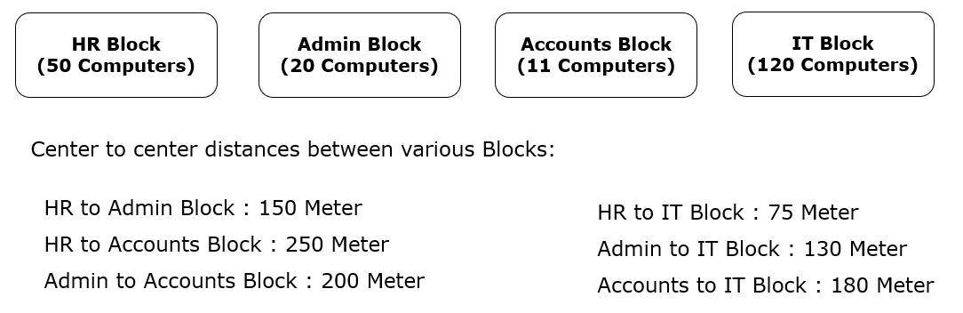
Computers in each Block are networked but Blocks are not networked with each other. The company has now decided to connect the wings also.
- Suggest the most appropriate network topology of the connection between the wings.
- Identify the block that can be designated as the Server for the Company.
- Suggest the placement of the following devices with justification if the company wants minimized network traffic:
- Repeater
- Hub / switch
- Name the device that will be required to protect the network from unwanted and unauthorized accesses from outside the network.
The company is planning to link its head office situated in New Delhi with the offices in hilly areas. Suggest a way to connect it economically.

